DIS-Afr-Benin-Trophy Head-Bronze-Early 20th c

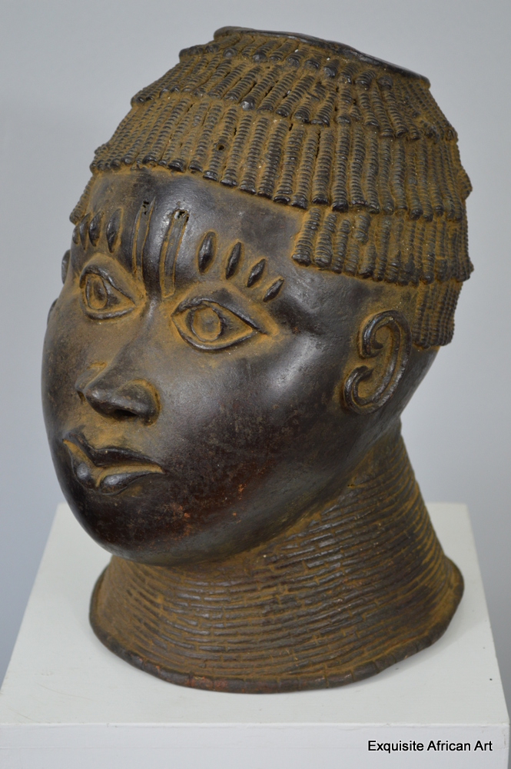

**Case No.: 6**

**Accession No.**

**Formal Label:** Benin bronze trophy head

**Display Description:**

**Accession Number:**

**LC Classification:**

**Date or Time Horizon:** early 20th c

**Geographical Area:** Nigeria

**Map:**

**GPS coordinates:**

**Cultural Affiliation:** Benin

**Medium:** bronze

**Dimensions:** cm: 31 tall x 19 wide x 24 depth

**Weight:** 4.2kg

**Condition:**

**Provenance:** Ref. Number: 0351 This piece was part of a very large old collection of African art from a sadly now deceased collector from Antwerp in Belgium. £1250.00

**Discussion:**

**References:**

Origin: Nigeria

Approx Age: Early 20th Century

Materials: Bronze

Dimensions cm: 31 tall x 19 wide x 24 depth x

Tribe: Benin

A stunning Benin bronze trophy head, this has been made using the old wax method and very well done. This is a piece that has real presence measuring 31cm tall and weighing 4.2kg. The finer detail is fantastic, on the inside of the head there is visible corrosion, the high neck collar represents coral beads, but the coral cap worn by Oba’s is not present.